Modul 1

Menuju Direktori Kerja.

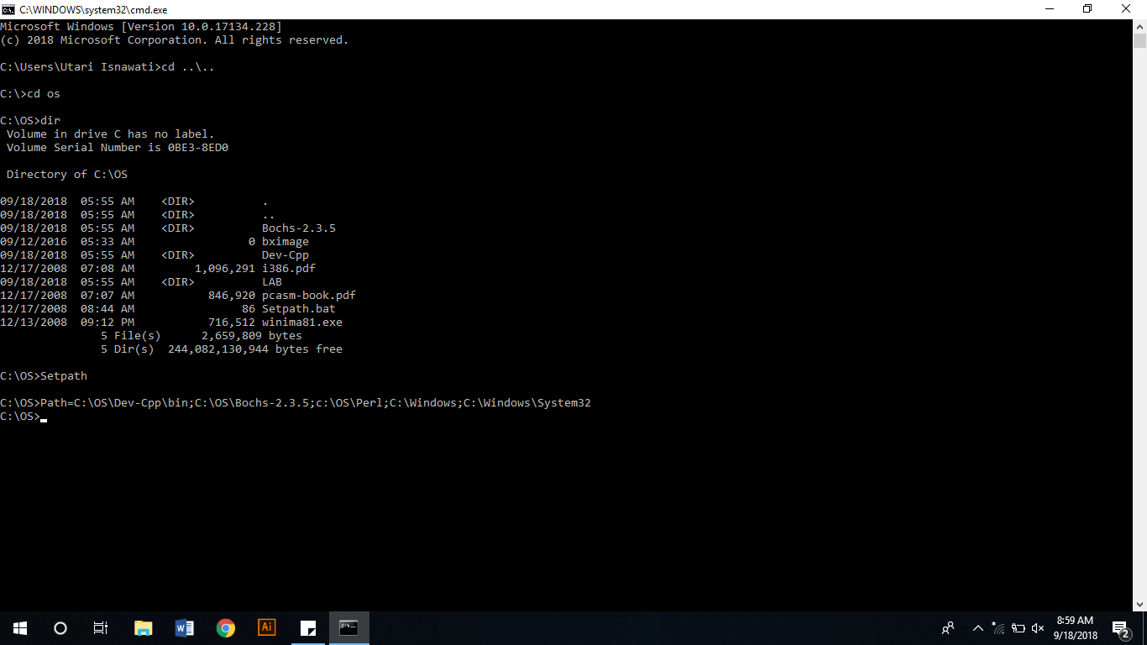

Melihat Isi Direktori Kerja.

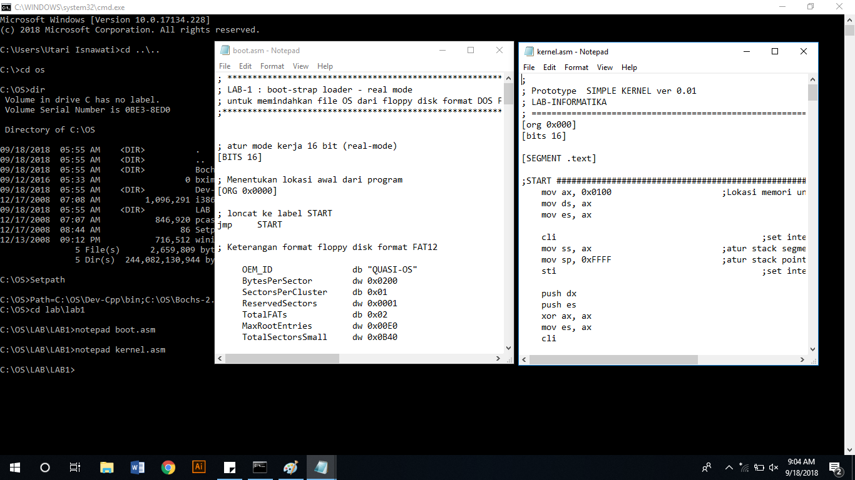

Makefile.

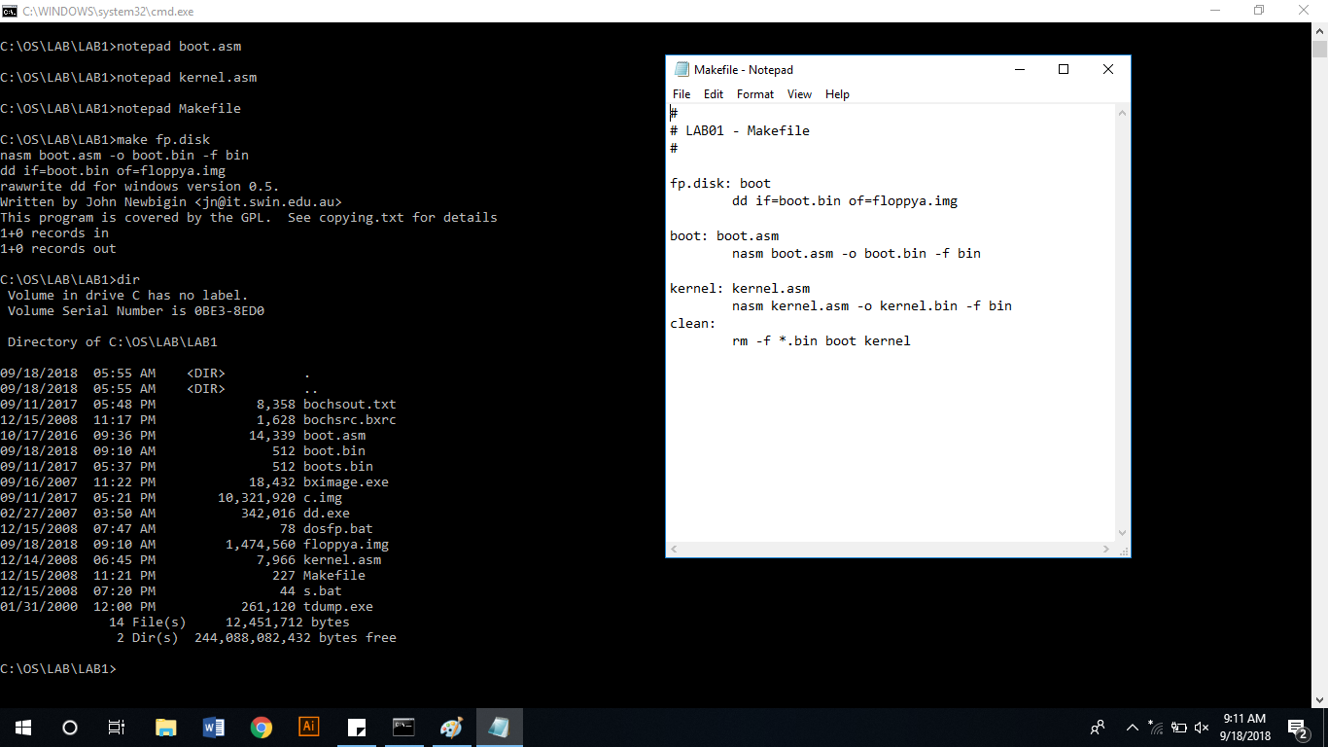

Make Clear

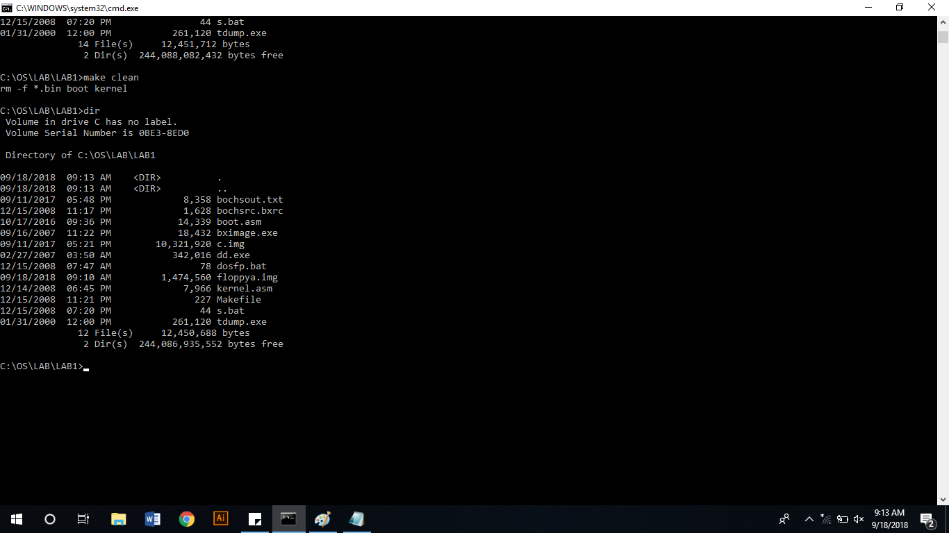

BOOT DISK

Membuat File Image Floppya.

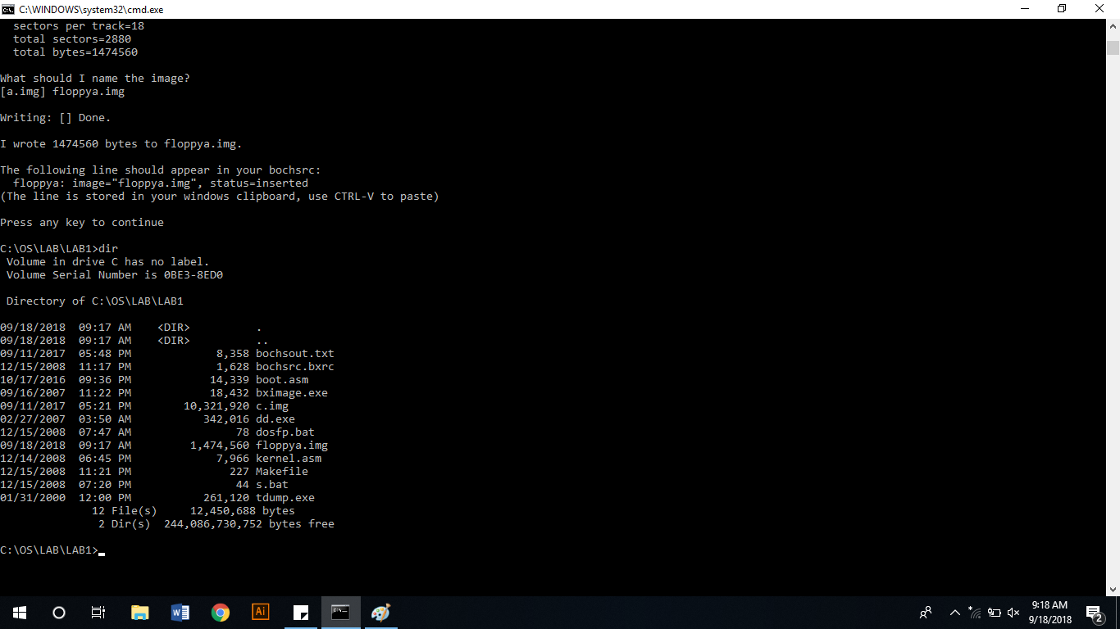

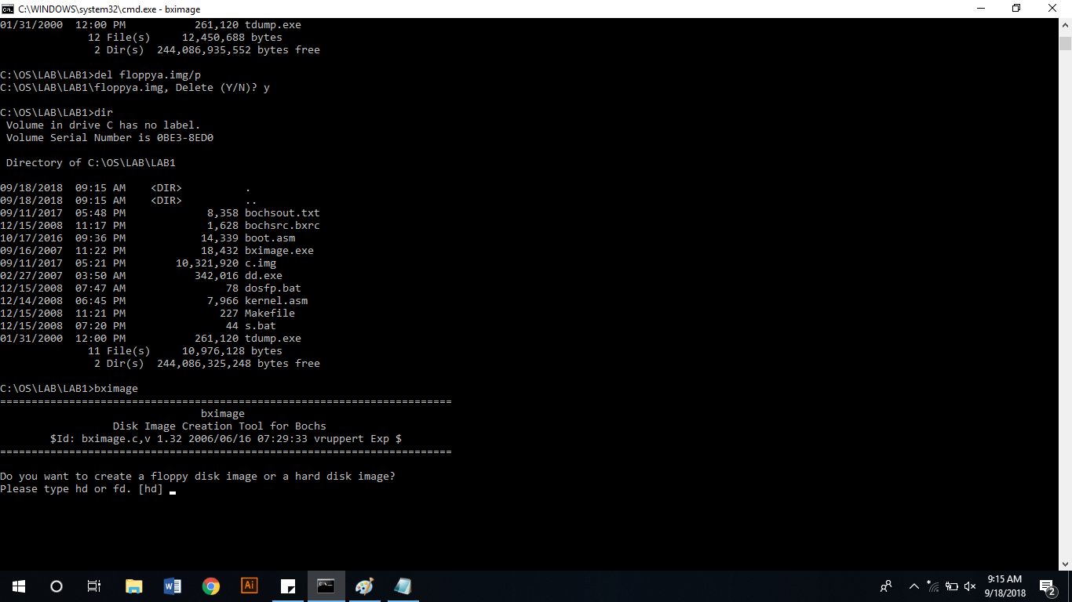

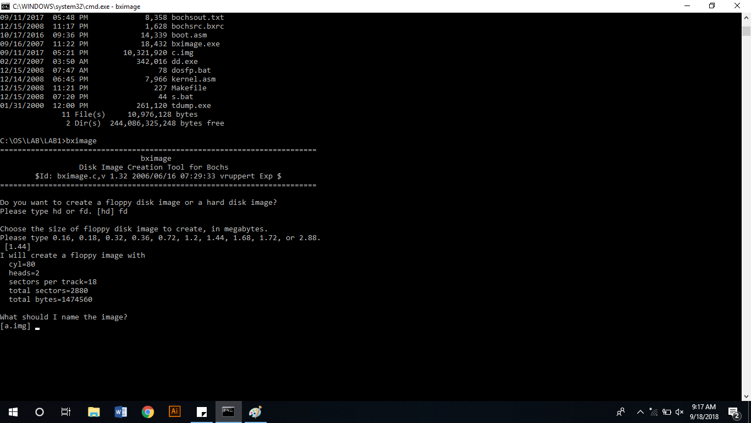

Format Floppya

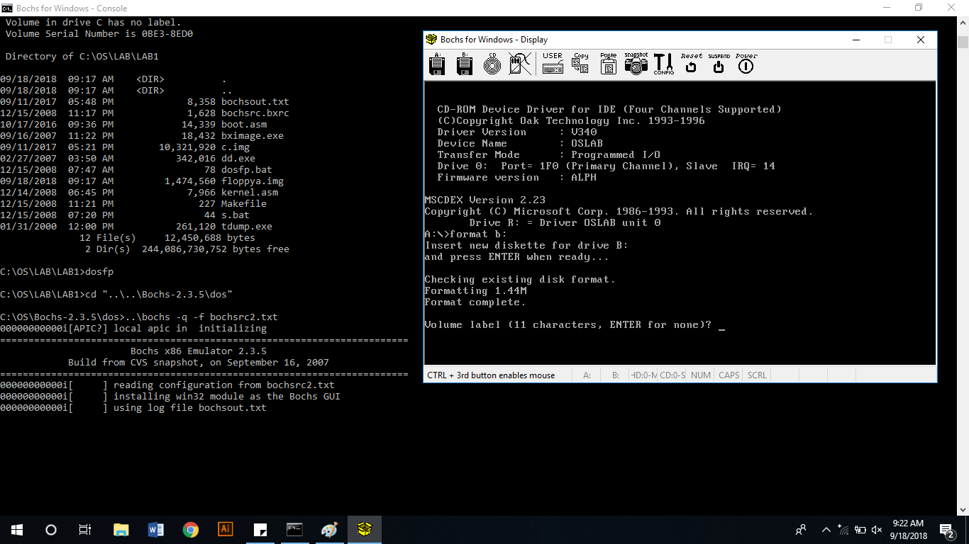

Data dalam bootsector file image floppya.img

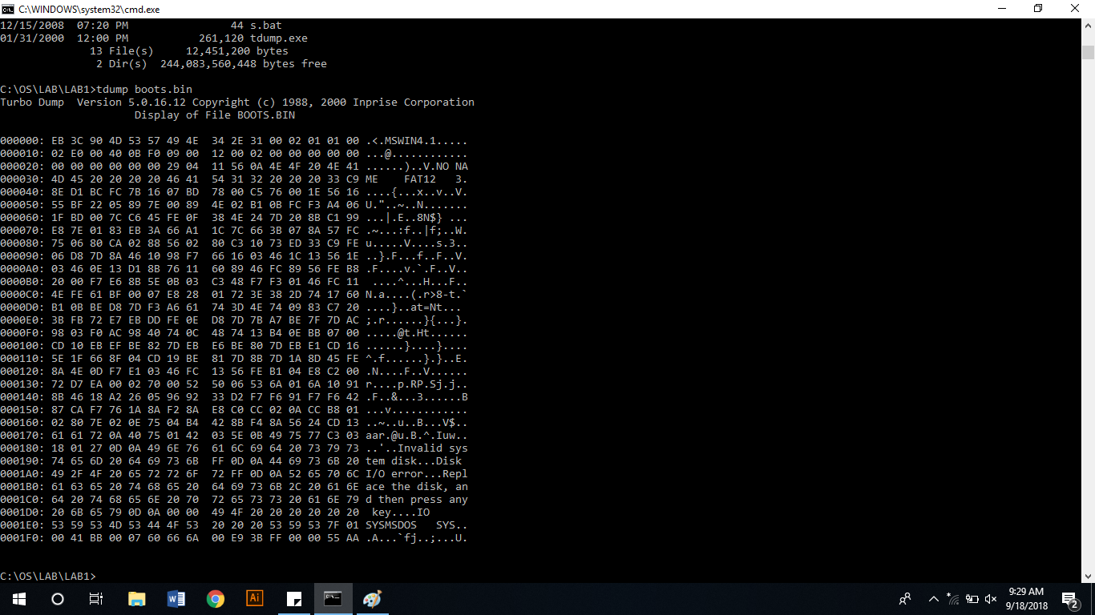

Boot PC-Simulator dengan file image ‘floppya.img’

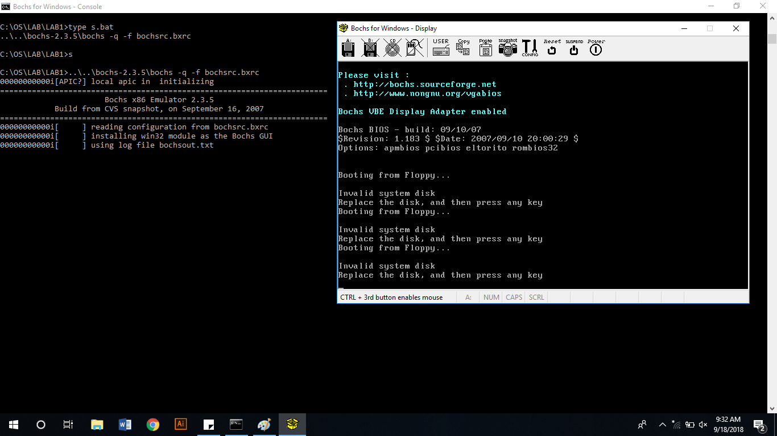

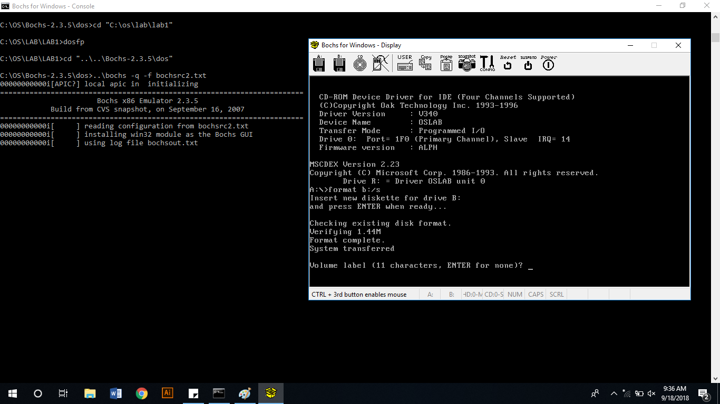

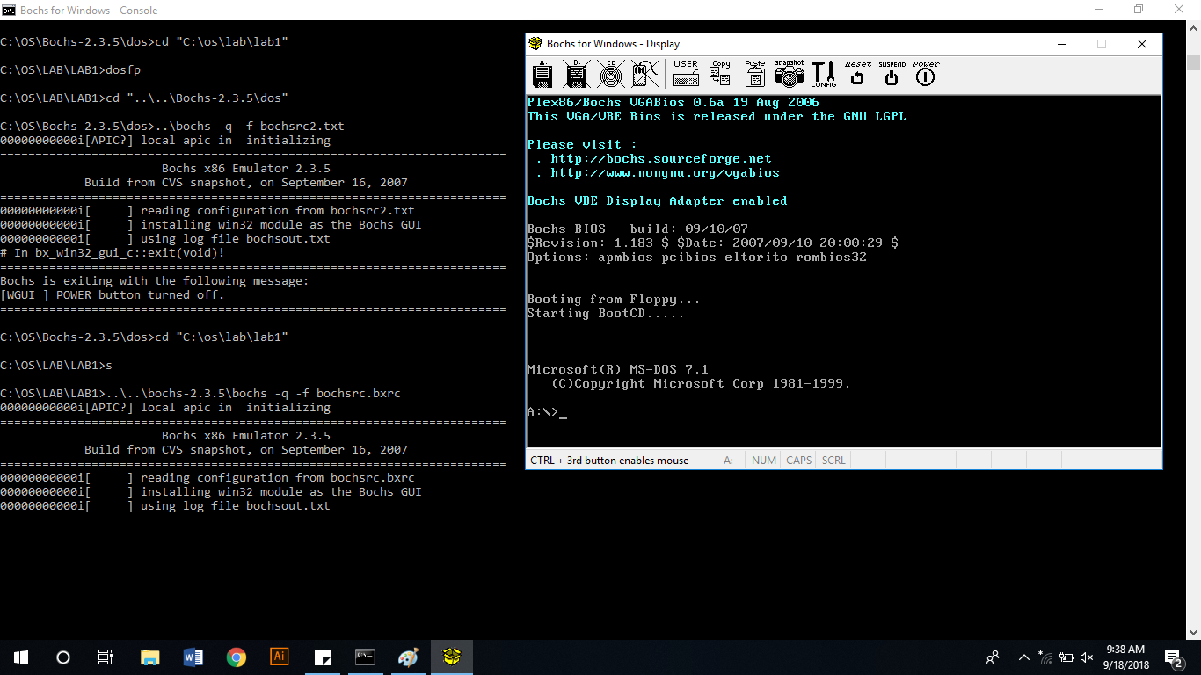

Tugas :

1. Apa yang dimaksud dengan kode ‘ASCII’, buatlah table kode ASCII lengkap cukup kode ASCII yang standar tidak perlu extended, tuliskan kode ASCII dalam format angka decimal, binary dan hexadecimal serta karakter dan symbol yang dikodekan.

Answer :

Short for American Standard Code for Information Interexchange, ASCII is a standard that assigns letters, numbers, and other characters in the 256 slots available in the 8-bit code. The ASCII decimal (Dec) number is created from binary, which is the language of all computers. As shown in the table below, the lowercase "h" character (Char) has a decimal value of 104, which is "01101000" in binary.

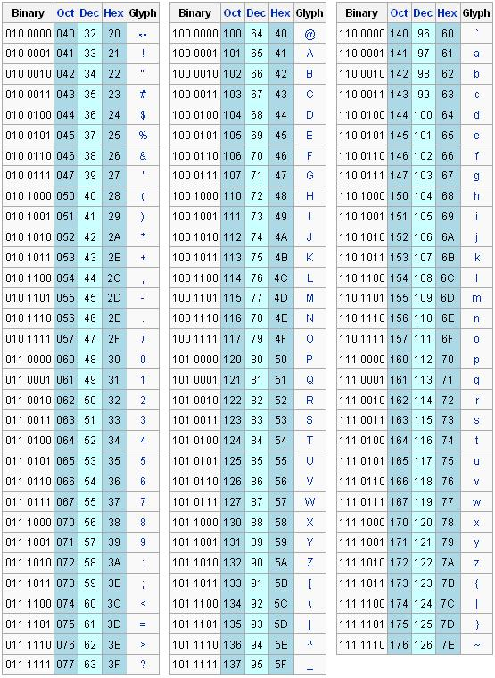

1. Carilah daftar perintah Bahasa assembly untuk mesin intel keluarga x86 lengkap (dari buku referensi atau internet). Daftar perintah ini dapat digunakan sebagai pedoman untuk memahami program ‘boot.asm’ dan ‘kernel.asm’.

Answer :

**Daftar Assembly Directive**

|  |  |
| --- | --- |
| **Assembly Directive** | **Keterangan** |
| EQU | Pendefinisian konstanta |
| DB | Pendefinisian data dengan ukuran satuan 1 byte |
| DW | Pendefinisian data dengan ukuran 1 word |
| DBIT | Perdefinisian data denga ukuran 1 bit |
| DS | Pemesanan tempat penyimpanan data di RAM |
| ORG | Inisialisasi alamat mulai program |
| END | Penanda akhir program |
| CSEG | Penanda penempatan di code segment |
| XSEG | Penanda penempatan di external data segment |
| DSEG | Penanda penempatan di internal direct data segment |
| ISEG | Penanda penempatan di internal indirect data segment |
| BSEG | Penanda penempatan di bit data segment |
| CODE | Penanda mulai pendefinisian program |
| XDATA | Pendefinisian external data |
| DATA | Pendefinisian internal direct data |
| IDATA | Pendefinisian internal indirect data |
| BIT | Pendefinisian data bit |
| #INCLUDE | Mengikutsertakan file program lain |

**Daftar Instruksi**

|  |  |
| --- | --- |
| **Instruksi** | **Keterangan Singkat** |
| ACALL | Absolute Call |
| ADD | Add |
| ADDC | Add with Carry |
| AJMP | Absolute Jump |
| ANJ | AND Logic |
| CJNE | Compare and Jump if Not Equal |
| CLR | Clear |
| CPL | Complement |
| DA | Decimal Adjust |
| DEC | Decrement |
| DIV | Divide |
| DJNZ | Decrement and Jump if Not Zero |
| INC | Increment |
| JB | Jump if Bit Set |
| JBC | Jump if Bit Set and Clear Bit |
| JC | Jump if Carry Set |
| JMP | Jump to Address |
| JNB | Jump if Not Bit Set |
| JNC | Jump if Carry Not Set |
| JNZ | Jump if Accumulator Not Zero |
| JZ | Jump if Accumulator Zero |
| LCALL | Lonf Call |
| LJMP | Long Jump |
| MOV | Move from Memory |
| MOVC | Move from Code Memory |
| MOVX | Move from Extended Memory |
| MUL | Multiply |
| NOP | No Operation |
| ORL | OR Logic |
| POP | Pop Value From Stack |
| PUSH | Push Value Onto Stack |
| RET | Return From Subroutine |
| RETI | Return From Interrupt |
| RL | Rotate Left |
| RLC | Rotate Left through Carry |
| RR | Rotate Right |
| RRC | Rotate Right throught Carry |
| SETB | Set Bit |
| SJMP | Short Jump |
| SUBB | Substract With Borrow |
| SWAP | Swap Nibble |
| XCH | Exchange Bytes |
| XCHD | Exchange Digits |
| XRL | Exclusive OR Logic |

Daftar Pustaka :

<https://www.computerhope.com/jargon/a/ascii.htm>

<https://tid3ustj.blogspot.com/2012/10/daftar-instruksi-bahasa-assembly.html>